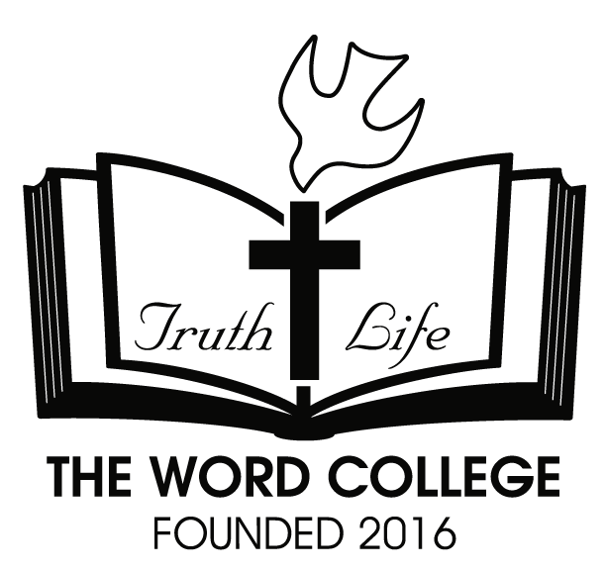 | THE WORD COLLEGE
 | 790 S. Carlin Springs Rd., Arlington, VA22204
 | Tel: 510-402-3681 | Fax:
 | www.twcusa.org | Email: blessckk@hanmail.net

Application for Admission
DEGREE PROGRAM ----------------------------------------------------------------------------------------------------
Select the area of study you are applying to:
o Associate of Biblical Studies o Bachelor of Theology o Master of Divinity
PERSONAL INFORMATION --------------------------------------------------------------------------------------
Provide all information below, this information will be kept confidential.
LAST NAME: ____________________________ FIRST NAME: _____________________________
MIDDLE NAME: ____________________________
ADDRESS (in US): _______________________________________________________________________
CITY: ___________________________ STATE: _______________________ ZIP CODE: _______________
ADDRESS (in F1 student's country):_________________________________________________________
________________ CITY: ________________________ PROVINCE/TERRITORY: __________________
ZIP CODE: _______________ COUNTRY: ____________________________
HOME PHONE: _____________________________ CELL PHONE: ________________________________
WORK TELEPHONE: ____________________________ EMAIL: _________________________________
PLACE OF BIRTH (CITY/COUNTRY): _____________________________/___________________________
COUNTRY OF CITIZENSHIP: ______________________ GENDER: o Male o Female
MARITAL STATUS: o Single o Married o Other
ETHNICITY (This information is voluntary and used for statistical purpose only): o African-American
o American Indian or Alaskan Native o Asian or Pacific Islander o Hispanic of Latino o Caucasian
o Other
LANGUAGE SPEAKS: _______________________ My English level is: ___________________________
STATUS: o B1/B2 o F1 o M1 o J1 o US/Permanent Resident or Citizen o Other
EDUCATION ----------------------------------------------------------------------------------------------------------------
Please list all colleges you have previously attended, including any you may not have received credit for:
HIGH SCHOOL: _______________________________________ CITY:_____________________________
COUNTRY: ______________________________ GRADUATION DATE: ____________________________
COLLEGES OR UNIVERSITIES:
NAME | CITY | COUNTRY | GRADUATION DATE | MAJOR | DEGREE

DEPENDENTS OF STUDENT (F1 Student only)---------------------------------------------------------------
LAST NAME | FIRST NAME | MIDDLE NAME | RELATIONSHIP | DATE OF BIRTH  (MM/DD/YYYY) | NATIONALITY | GENDER
 |  |  |  |  |  | FEMALE | MALE

ADMISSIONS REQUIREMENTS -------------------------------------------------------------------------------
* For U.S. Resident Applicants
1. This application must to be completed, signed, and submitted to the Admissions office with a $100 non-refundable application fee.
2. Submit a photocopy of the front page of valid passport (with the picture, the name and the birth date) or ID card.
3. Copy of a high school diploma or college transcript

* For International Applicants (I-20 Required)
1. This application must to be completed, signed, and submitted to the Admissions office with a $100 non-refundable application fee.
2. Submit a photocopy of the front page of valid passport (with the picture, the name and the birth date) or ID card online.
3. Copy of a high school diploma or college transcript, translated in English and notarized
4. Mail an original copy of a bank statement that shows available funds to afford the program and the cost of living. (Note: All financial information must be statements with dates no older than 3 months prior to the I-20 application date.)
5. Mail the Affidavit of Support Form by the sponsor (if applicable).
6. A proof of English or Korean language proficiency: If English is not your first language, you are required to summit official scores from an English proficiency examination, regardless of citizenship. (Example: TOEFL Score of at least 61 iBT or a level 6 IELTS exam or C1 level in Oxford English Test) . It is not requirement for E.S.L.. Korean language competency requirement maybe fulfilled through an interview with the Academic Dean of Biblical Studies.
7. Transfer students only: mail a photocopy of all I-20 forms from previous schools in the U.S. to College office.
8. Transfer students only: mail a photocopy of the current visa and I-94.

INSTITUTIONAL AGREEMENT --------------------------------------------------------------------------------
1. The Word College has identified the above data as directory information as required by the Privacy Rights of Parents and Student Act. The School will release address, telephone number, dates of attendance, major program, credit hours and degree earned, and honors received unless a student requests in writing that the information not be released. All other data on the application will be held confidential and not released, except as required by law, without the student's permission.
2. I abide and agree with the doctrinal position of the College, as found in the doctrinal statement of the student catalog.
3. I certify that I've received a current The Word College catalog and I understand that I am responsible for adhering to all policies and procedures of the Academy. I also certify that the information given in this application is complete and accurate. I understand that withholding or giving false information will make me ineligible for admission or result in dismissal from The Word College.

The mission of The Word College is to develop a world Christian leader who equipped with the Word of God for serving the people in the world.

I understand and/or agree to the above statements in their entirety.

Signature: ________________________________________________ Date: ______________________

